BÀI ÔN TATC KHỐI 1 LẦN 10

TUẦN TỪ 3/5 ĐẾN 7/5

1.TOYS
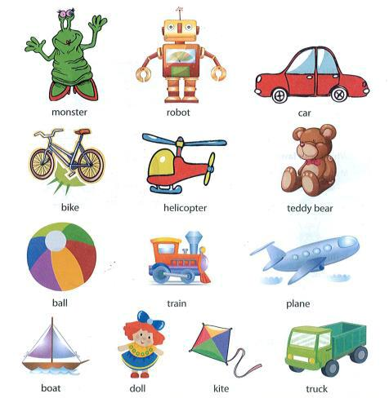

1
2. Unscramble the letters
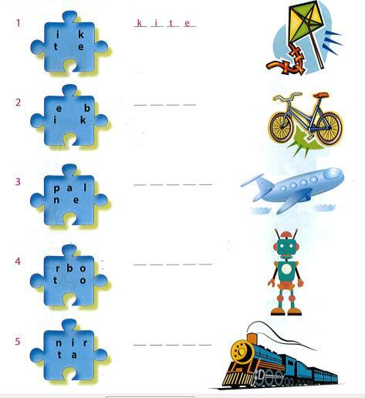

2
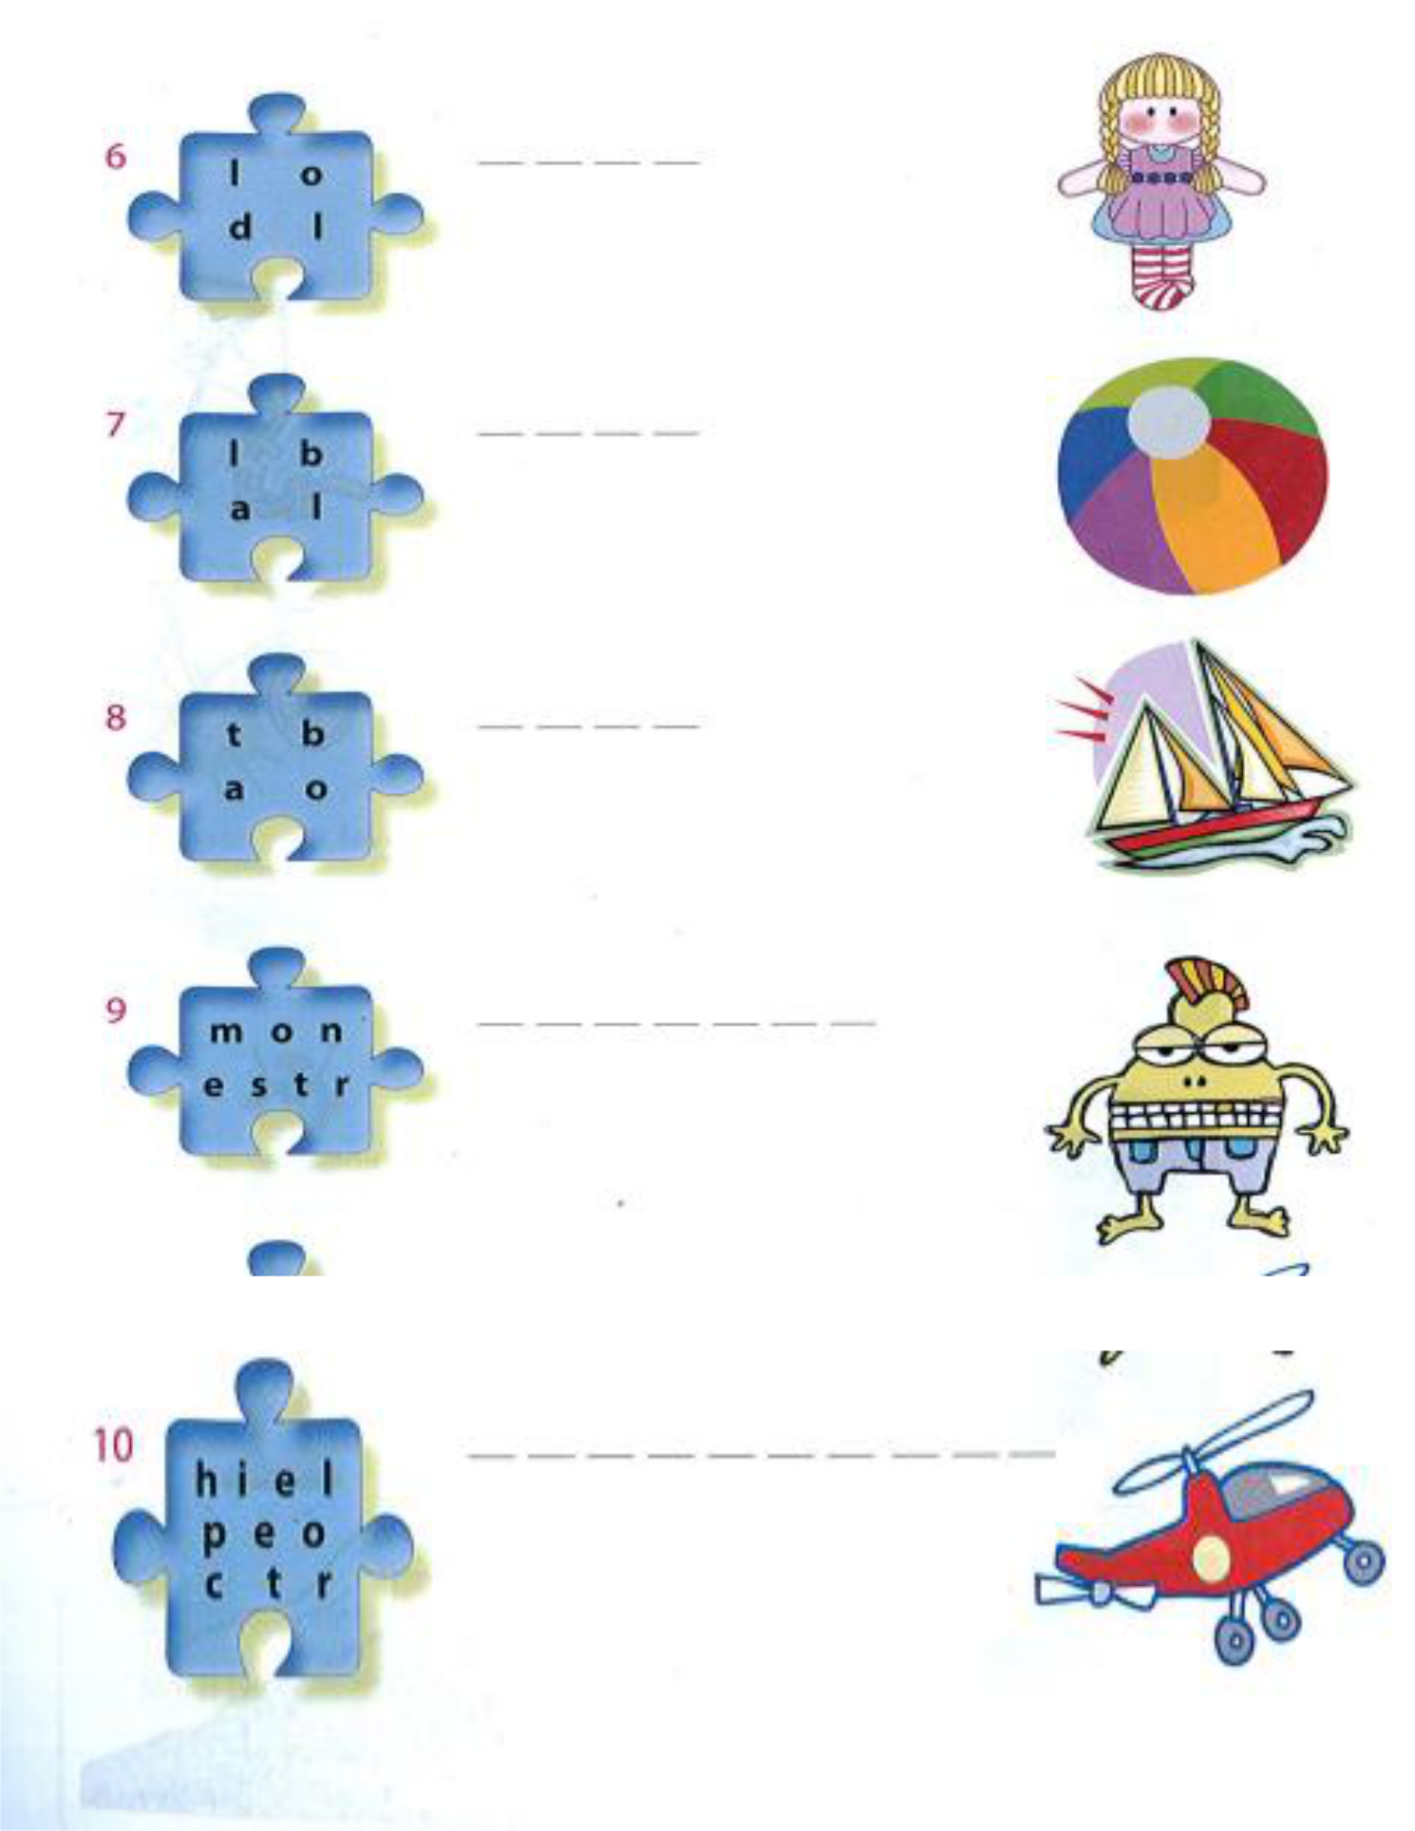

3
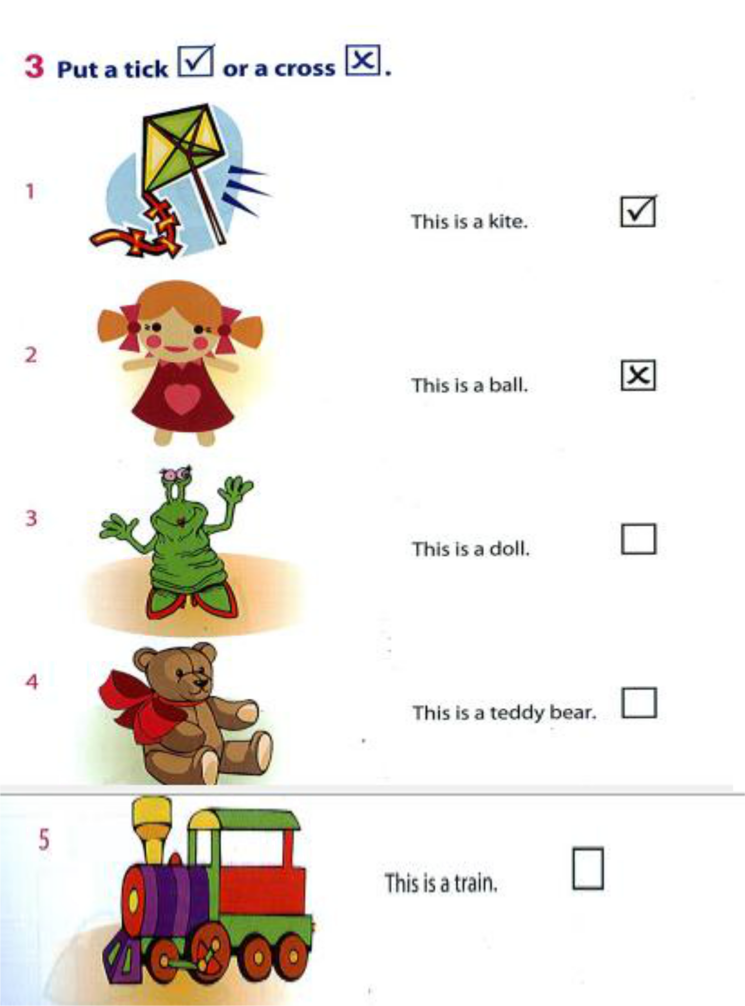

4
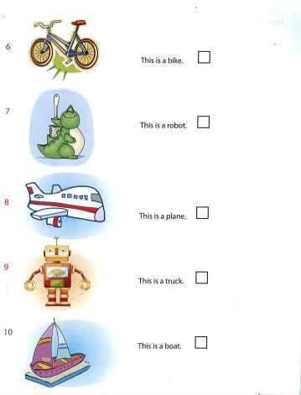

5
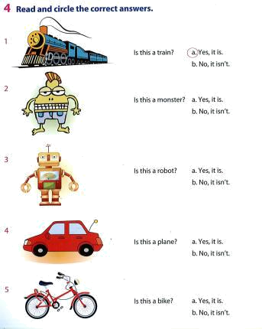

6
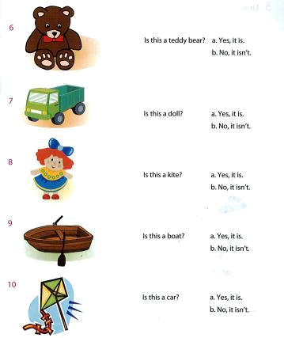

7
5.Read and color
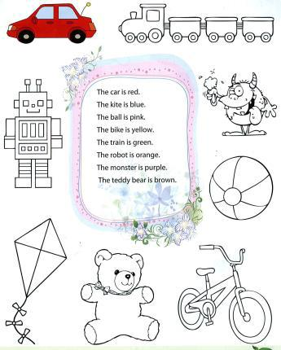

8
COPY WORDS

1. car

-----------------------------------------------------------------------------------------

-----------------------------------------------------------------------------------------

-----------------------------------------------------------------------------------------

2. plane

-----------------------------------------------------------------------------------------

-----------------------------------------------------------------------------------------

---------------------------------------------------------------------------------------

3. robot

-----------------------------------------------------------------------------------------

-----------------------------------------------------------------------------------------

-----------------------------------------------------------------------------------------

4. teddy bear

----------------------------------------------------------------------------------------

----------------------------------------------------------------------------------------

9

